**PRACTICAL 2: Creating account, repository on Github s and cloning**

**repository in Github**

**a) Creating account: -**

**Step1: - Search Github on Google and click on the official link of**

**Github.**

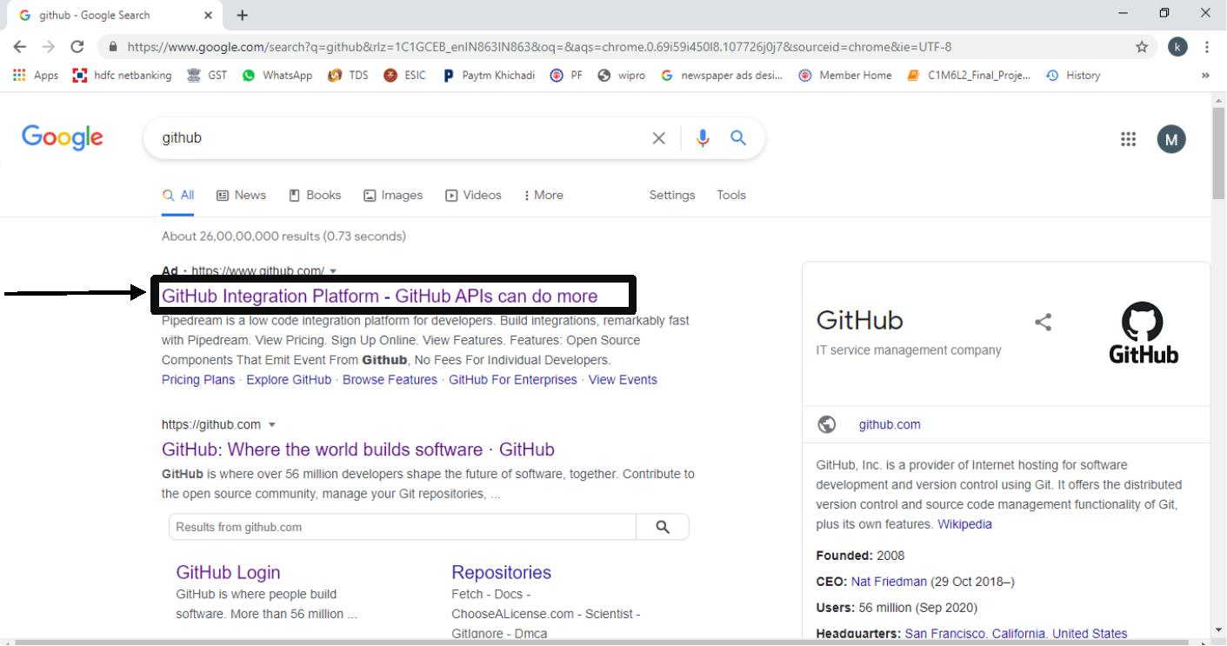

Name: - komal menaria

Roll No: 42

Class: FYBSCIT

**Step 2: Click on the sign up button to create an account on Github.**

**Step 3: When you click on the signup button you will reach on this**

**here you have to fill all necessary information which is star marked.**

**page**

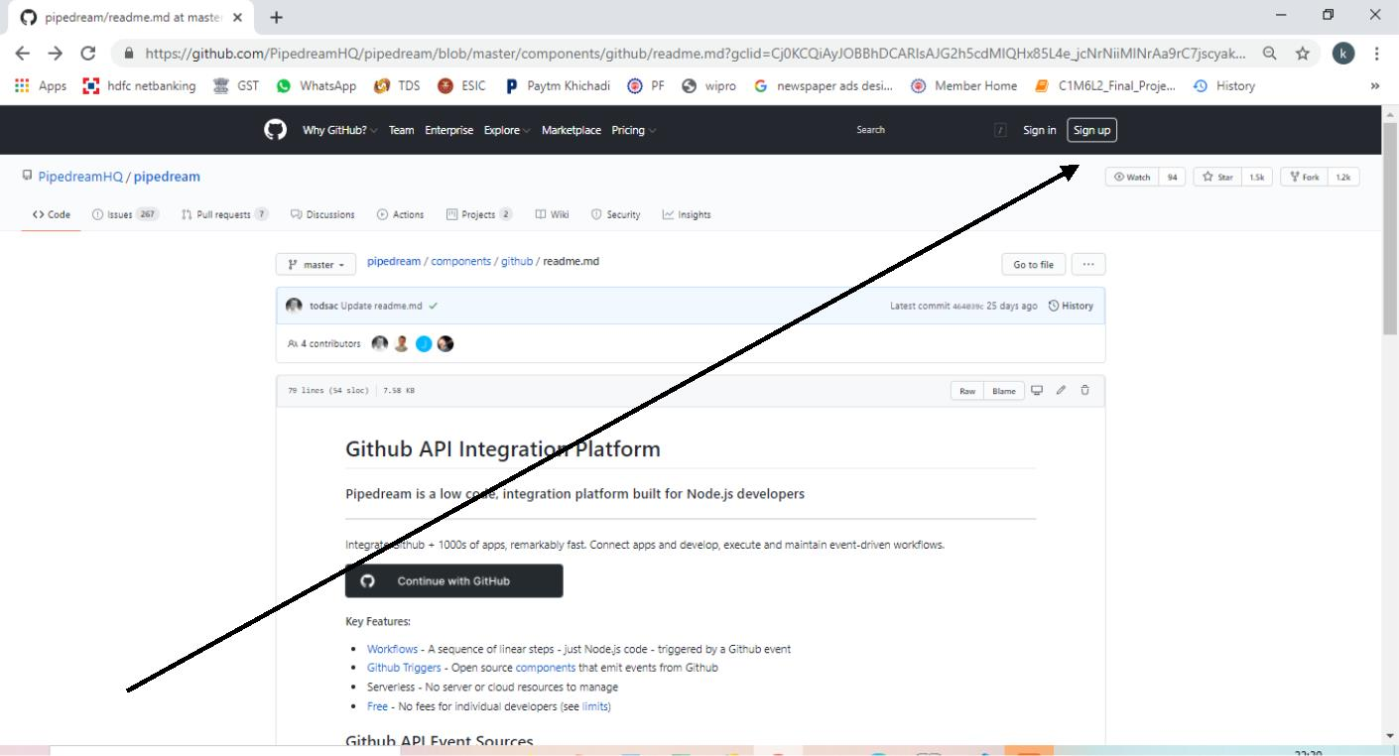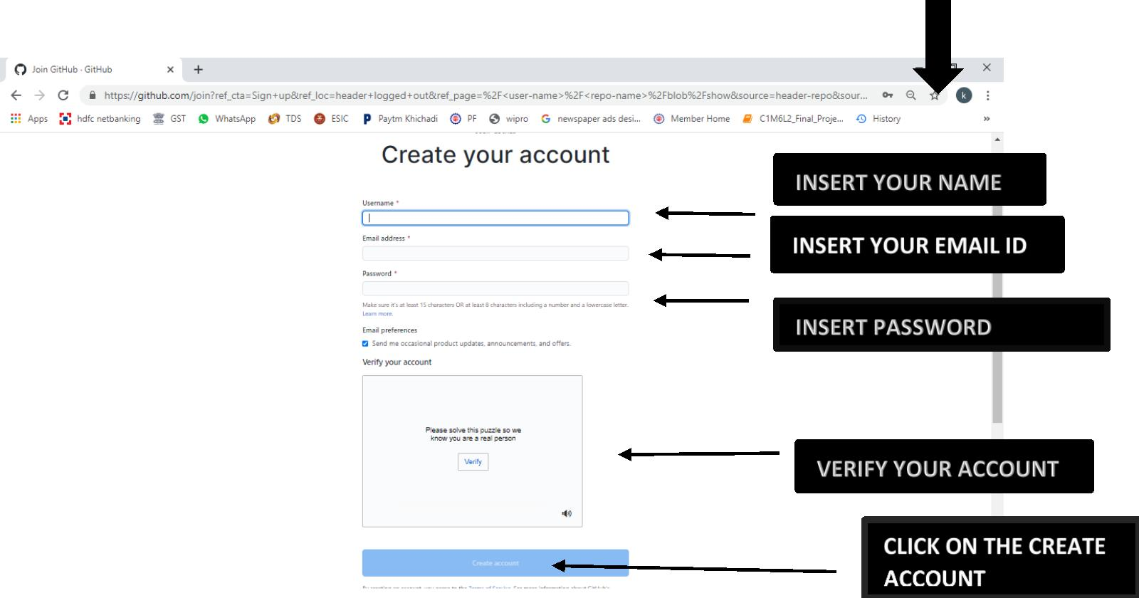

Name: - komal menaria

Roll No: 42

Class: FYBSCIT

**Step 4: After fill all the information verify your account and click on the**

**Create Account button. Now your account is created.**

**b) Creating repository:**

**Step 1: To create repository click on the + button .**

**Step 2: Click on New repository to make your repository.**

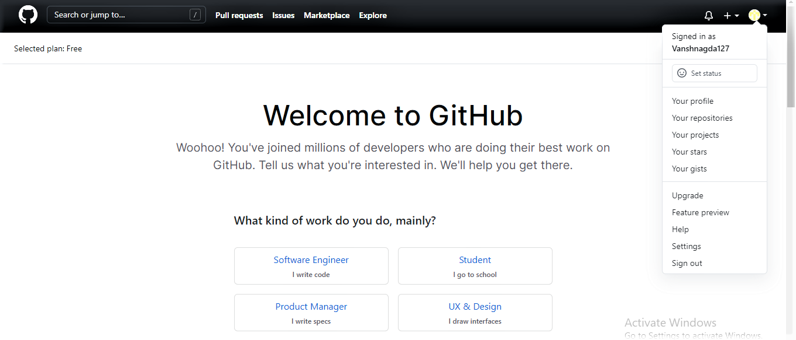

Name: - komal menaria

Roll No: 42

Class: FYBSCIT

**Step 3: After clicking on the New repository you reach on this page here you**

**have to give your Repository name, click on the private or public button.**

**Description: It is optional, so if you want to describe something about your**

**repository then fill the description field with necessary information**

**1 Private: If you want no one can access your repository then click on private**

**button.**

**2 Public: If you want other people can access your repository then click on**

**public button.**

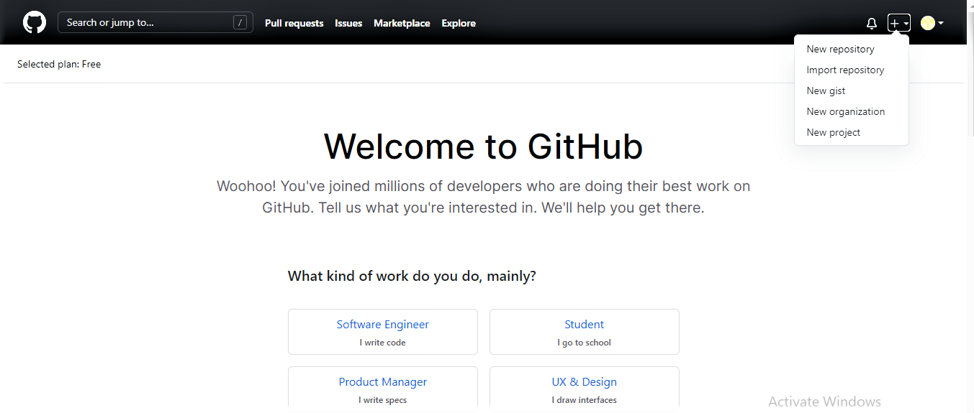

Name: - komal menaria

Roll No: 42

Class: FYBSCIT

SELECT ONE OF THEM

**Step 4: In the last click on the create repository button.**

**c) Cloning repository:**

**After clicking on the create repository button you will reach on this page**

**Step 1:Click on the Add file button .**



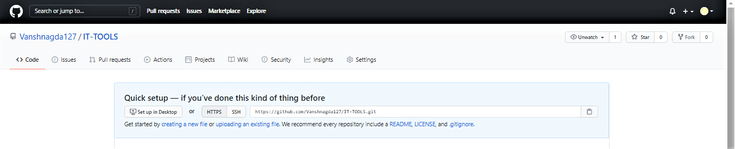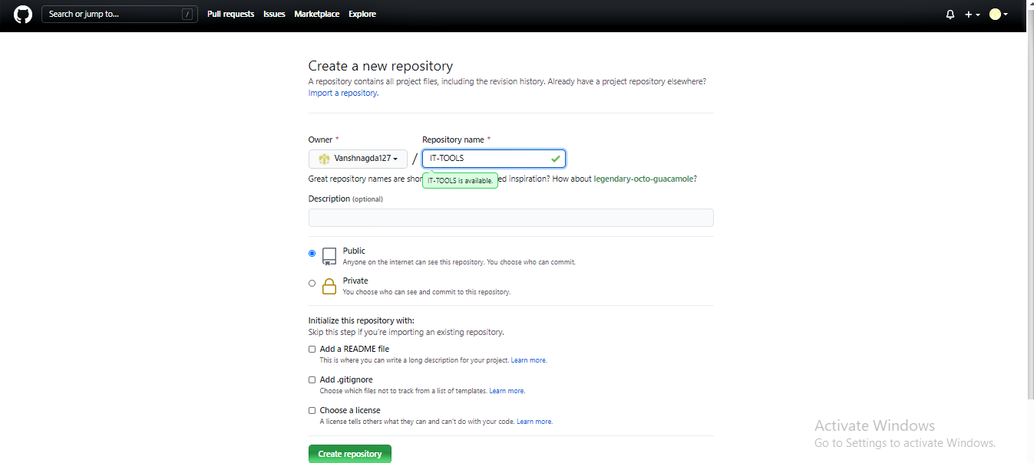

CLICK HERE TO ADD YOUR FILE

CLICK ON CREATE REPOSITORY BUTTON

SELECT ONE OF THEM

DESCRIPTION ABOUT YOUR REPOSITORY

NAME OF YOUR REPOSITORY

**Step 2 click on upload files here you can add any no of file in the repository.**

**Step 3: Click on choose your files to select your file.**

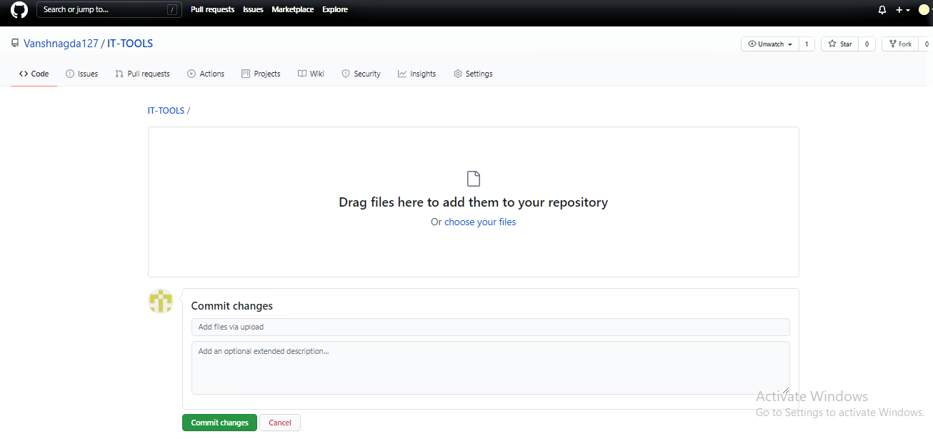

**Step 4: Select the file which you want and click on open button and atlast**

**click on the commit changes button to save the changes.**

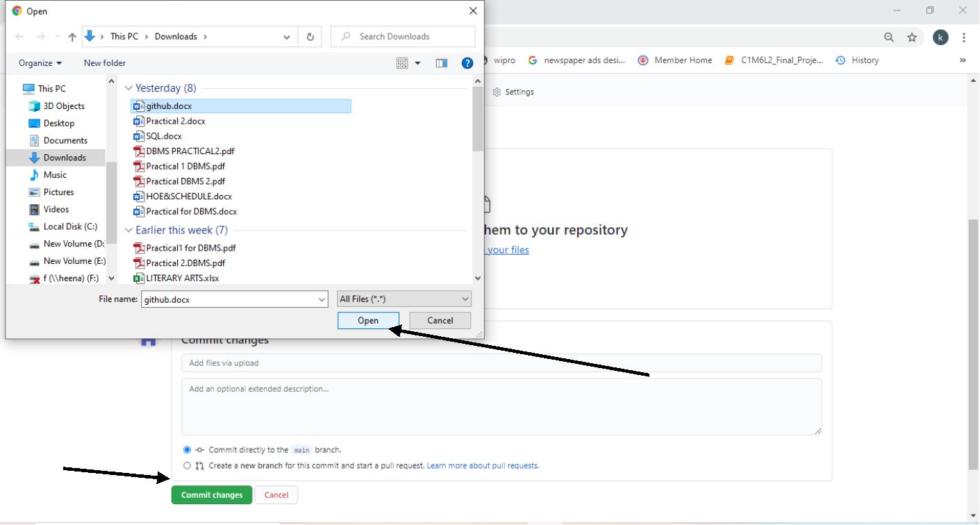

Name: - komal menaria

Roll No: 42

Class: FYBSCIT

**Step 4: click on the code button to get your repository link and copy the link**

**To share your repository.**

LINK OF THE REPOSITORY

